<https://relicelectrical.ca/products/dc-24v-480w-ip20-universal-regulated-switching-led-transformer>

Schatting:

24V - 3A

60m = 24V - 36A

voeding aan elke kant parallel geschakeld 24V - 18A

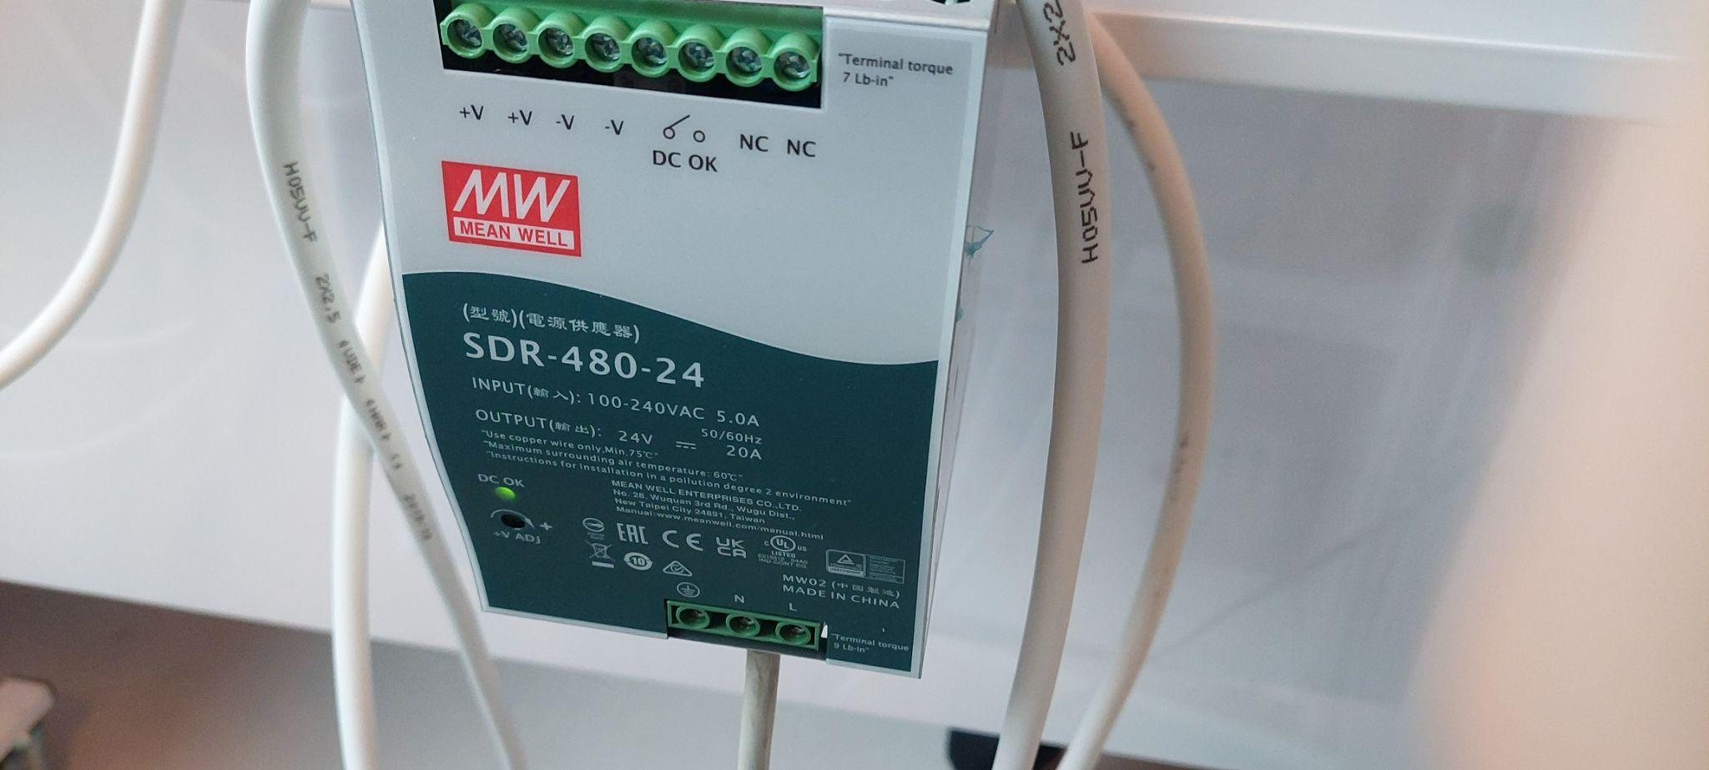

2X SDR 480-24

<https://www.meanwell-web.com/en-gb/ac-dc-industrial-din-rail-power-supply-output-sdr--480--24>

Output Power (W) → 480

Output Voltage (V) → 24

Output Current (A) → 20

<https://www.meanwell-web.com/en-gb/shop/basket> dubbel fack

aansluiting Naar Net

Ground

2 Powers

output V+ en V-